Hong Kong Exchanges and Clearing Limited and The Stock Exchange of Hong Kong Limited take no responsibility for the contents of this announcement, make no representation as to its accuracy or completeness and expressly disclaim any liability whatsoever for any loss howsoever arising from or in reliance upon the whole or any part of the contents of this announcement.

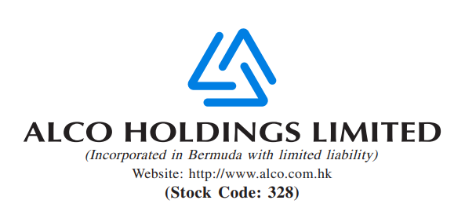
INSIDE INFORMATION – WITHDRAWAL OF THE WINDING-UP PETITION

This announcement is issued by Alco Holdings Limited (the “Company”) pursuant to Rules 13.09 and 13.25 of the Rules Governing the Listing of Securities (the “Listing Rules”) on The Stock Exchange of Hong Kong Limited (the “Stock Exchange”) and the Inside Information Provisions (as defined under the Listing Rules) under Part XIVA of the Securities and Futures Ordinance (Chapter 571 of the Laws of Hong Kong).

Reference is made to the announcements of the Company dated 31 August 2023, 22 September 2023, 25 October 2023, 1 November 2023 3, 3 January 2024, 24 January 2024 and 6 March 2024 in relation to the winding up petition filed by Shanghai Commercial Bank Limited against the Company (the “Announcements”). Unless the context otherwise specified, capitalised terms used herein shall have the same meanings as those defined in the Announcements.

The Company hereby announces that during today’s hearing, both parties agreed on the legal costs and the Petition is fully withdrawn.

Hong Kong, 20 March 2024
By Order of the Board
Alco Holdings Limited
Liang Yanan
Chairman
As at the date of this announcement, the executive directors of the Company are Mr. HO Chak Yu and Mr. LIANG Yanan. Non-executive director of the Company is Mr. YANG Min. Independent non-executive directors of the Company are Mr. CHU Hoi Kan, Mr. LAM Chi Wing, Mr. TANG Sher Kin, Mr. DENG Chaowen and Ms. MAK Suet Man.

