Hong Kong Exchanges and Clearing Limited and The Stock Exchange of Hong Kong Limited take no responsibility for the contents of this announcement, make no representation as to its accuracy or completeness and expressly disclaim any liability whatsoever for any loss howsoever arising from or in reliance upon the whole or any part of the contents of this announcement.
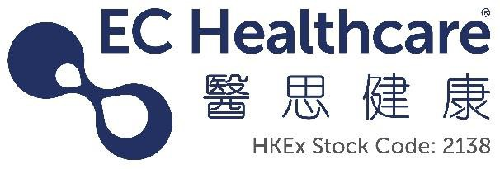

EC Healthcare

醫思健康
(Incorporated in the Cayman Islands with limited liability)
(Stock Code: 2138)

DATE OF BOARD MEETING

The board of directors (the “Board”) of EC Healthcare (the “Company”) hereby announces that a meeting of the Board will be held on Thursday, 30 November 2023 for the purposes of, among other matters, considering and approving the interim results of the Company and its subsidiaries for the six months ended 30 September 2023 and considering payment of an interim dividend, if any.

By Order of the Board
EC Healthcare
Raymond Siu
Company Secretary

Hong Kong, 15 November 2023

As at the date of this announcement, the executive Directors are Mr. Tang Chi Fai, Mr. Lu Lyn Wade Leslie, Mr. Lee Heung Wing and Mr. Wong Chi Cheung; the non-executive Director is Mr. Luk Kun Shing Ben; and the independent non-executive Directors are Mr. Ma Ching Nam, Mr. Look Andrew and Mr. Au Tsun.

