Hong Kong Exchanges and Clearing Limited and The Stock Exchange of Hong Kong Limited take no responsibility for the contents of this notice, make no representation as to its accuracy or completeness and expressly disclaim any liability whatsoever for any loss howsoever arising from or in reliance upon the whole or any part of the contents of this notice.
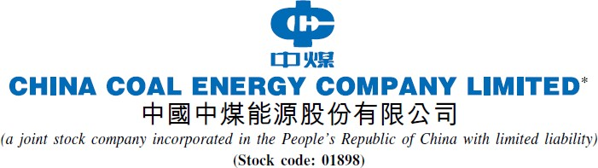

NOTICE OF BOARD MEETING

The board of directors (the “Board”) of China Coal Energy Company Limited (the “Company”) hereby announces that a meeting of the Board will be held on Thursday, 24 August 2023, for the purpose of, considering and approving, among other matters, the interim results of the Group (comprising the Company and its subsidiaries) for the six months ended 30 June 2023.

By Order of the Board

China Coal Energy Company Limited Wang Shudong
Chairman of the Board, Executive Director

Beijing, the PRC
9 August 2023

As at the date of this notice, the executive directors of the Company are Wang Shudong, Peng Yi, Liao Huajun and Zhao Rongzhe; non-executive director is Xu Qian; independent non-executive directors are Zhang Chengjie, Jing Fengru and Hung Lo Shan Lusan.

* For identification purpose only

1

